Observation report for

JavaScript Algorithm 1

Rodney R. Giray Date: January 6, 2023

Instructor: Alfren James Cabuquit WD37

Level 1 Activity 1 - When I try first Coding I was confused, in this picture I will print the value of x using console.log(x).

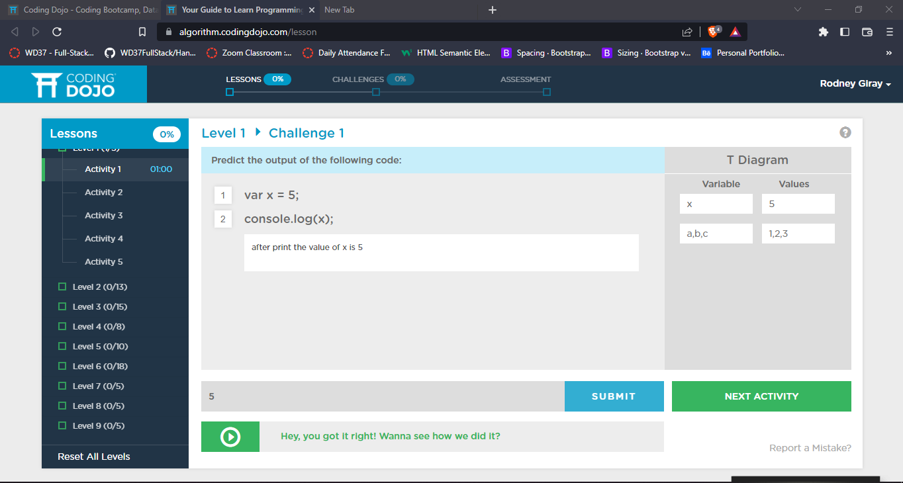

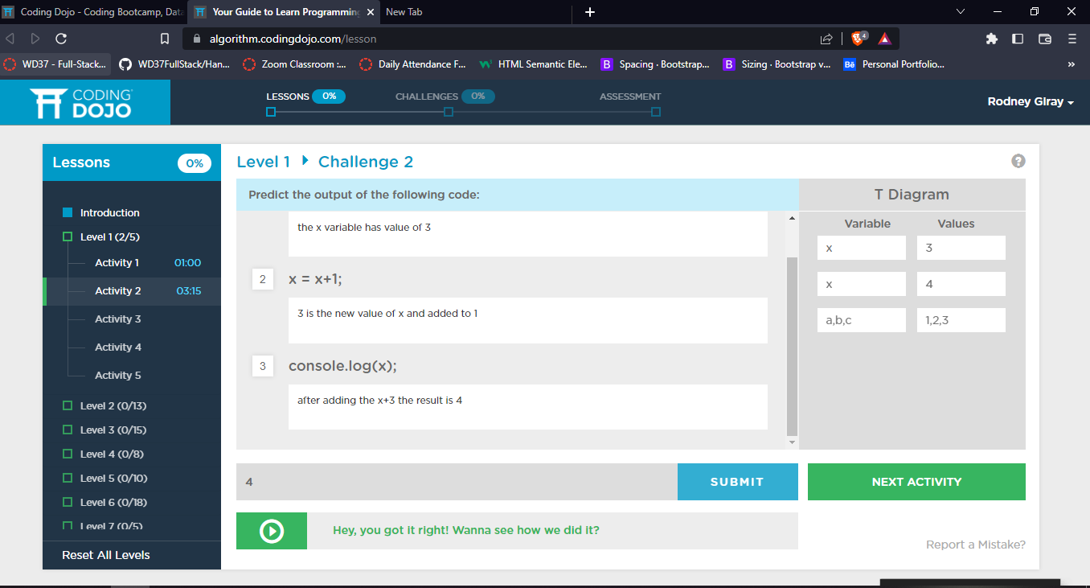Level 1 Activity 2 – In this picture I noticed that the code x+1 will first to give the value to x which is on the left side.

Level 1 Activity 3 – In this picture it took me 25mins to figure out the answer, because, it need to print the first value of x

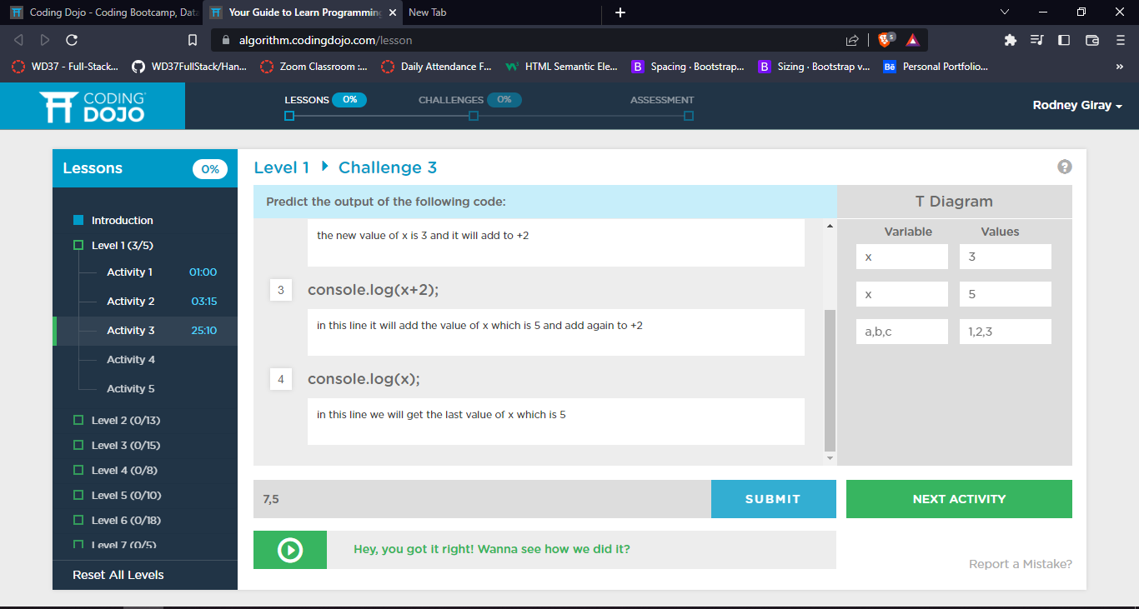

Level 1 Activity 4 – In this picture, I noticed that you can do arithmetic operation while inside the parenthesis of console.log.

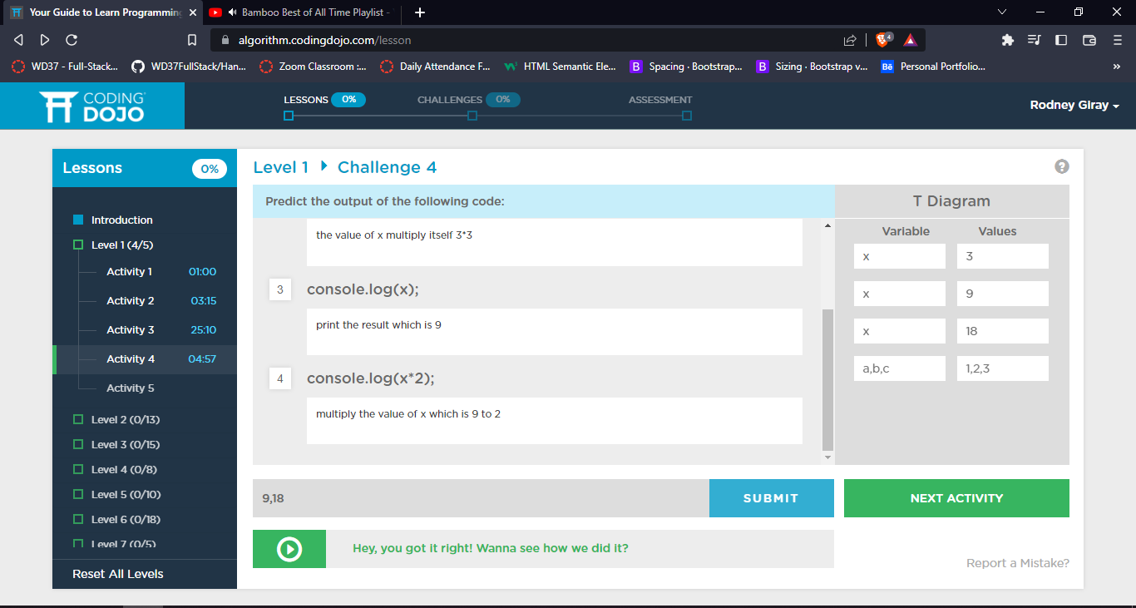

Level 1 Activity 5 – In this picture, the introduced using the 3 variables and set a value by adding the two value of variables.

